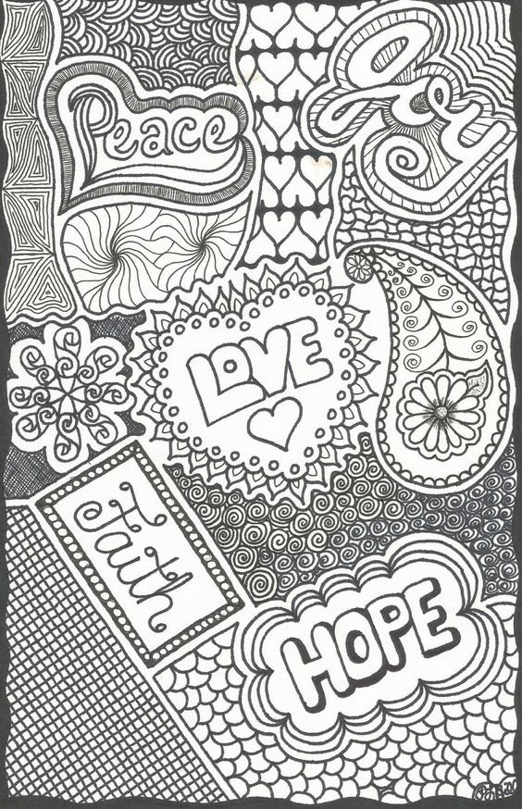
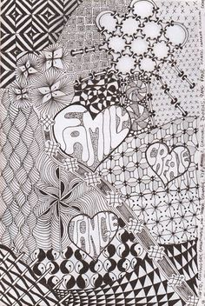
Zentangle with a Message
DAY 2
Project Goal:
You will build on your previous understanding of zentangles and you will be adding a positive message within your composition. In keeping with the concept of zentangles, your composition will consist of beautiful and intricate tangles ‘patterns’ that are separated by a fluid line ‘string.’

Project requirements:
3 words that are inspirational and hopeful.
The words should have a hierarchy of structure - meaning 1 should stand out as the most important, through scale and boldness. The other 2 words will be the supporting words and be smaller and less noticeable.
At least 10 sections with different Zentangles in them.

Day 2 Procedures:
- View the slideshow to review Zentangles
- Start filling in some of your sections with Zentangles.
- There are a lot of Zentangle ideas on the slideshow but google more if you need it.
- TAKE YOUR TIME! I do not want to see a bunch of stripes and checkerboards
- Use a BLACK pen or marker for everything. One color only!!
- Do not use a ruler, this should just flow and doesn’t have to be perfect.
- Vary your lines, some are thin, some are thick, some areas are colored in black
- Work around your words, but don’t outline the words yet.
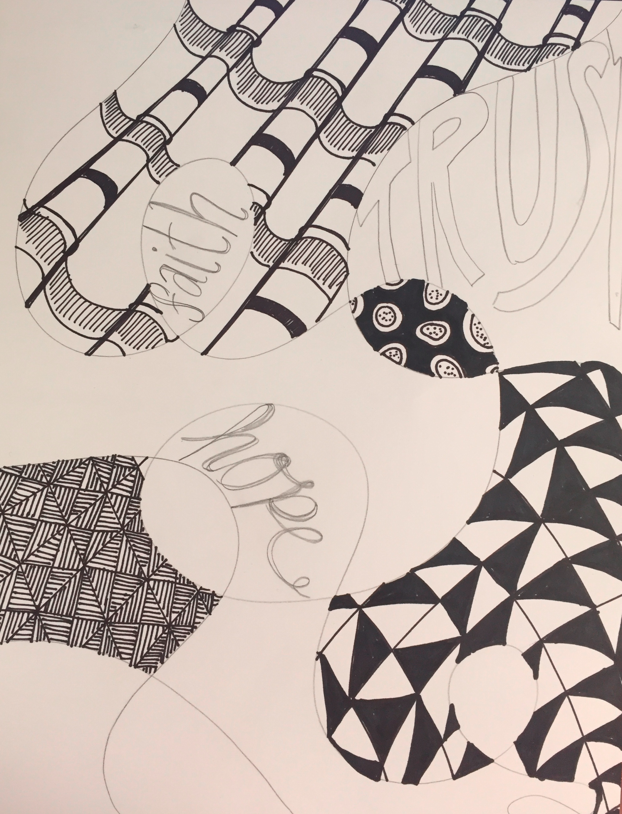
- You should get ⅓ of your paper done TODAY.
- Take a picture and upload to Classroom.

This is my progress for the day so you can see how much to get done.

